**ITT-307 Host Hardening**

**Professor:** Prof. McCrea

**Course:** ITT-307

**Student:** Aiden Yoshioka

**Date:**  02 February 2020

**Title:** Benchmark - Host Hardening

**Directions:**

# Overview:

# This assignment is meant to demonstrate they techniques and knowledge we have learned in class. The student is to apply their knowledge on how to protect a computer from an attacker, by using different techniques.

# Details:

**Disable all USB ports so no bad USB attacks or USB rubber duckies can be used.**

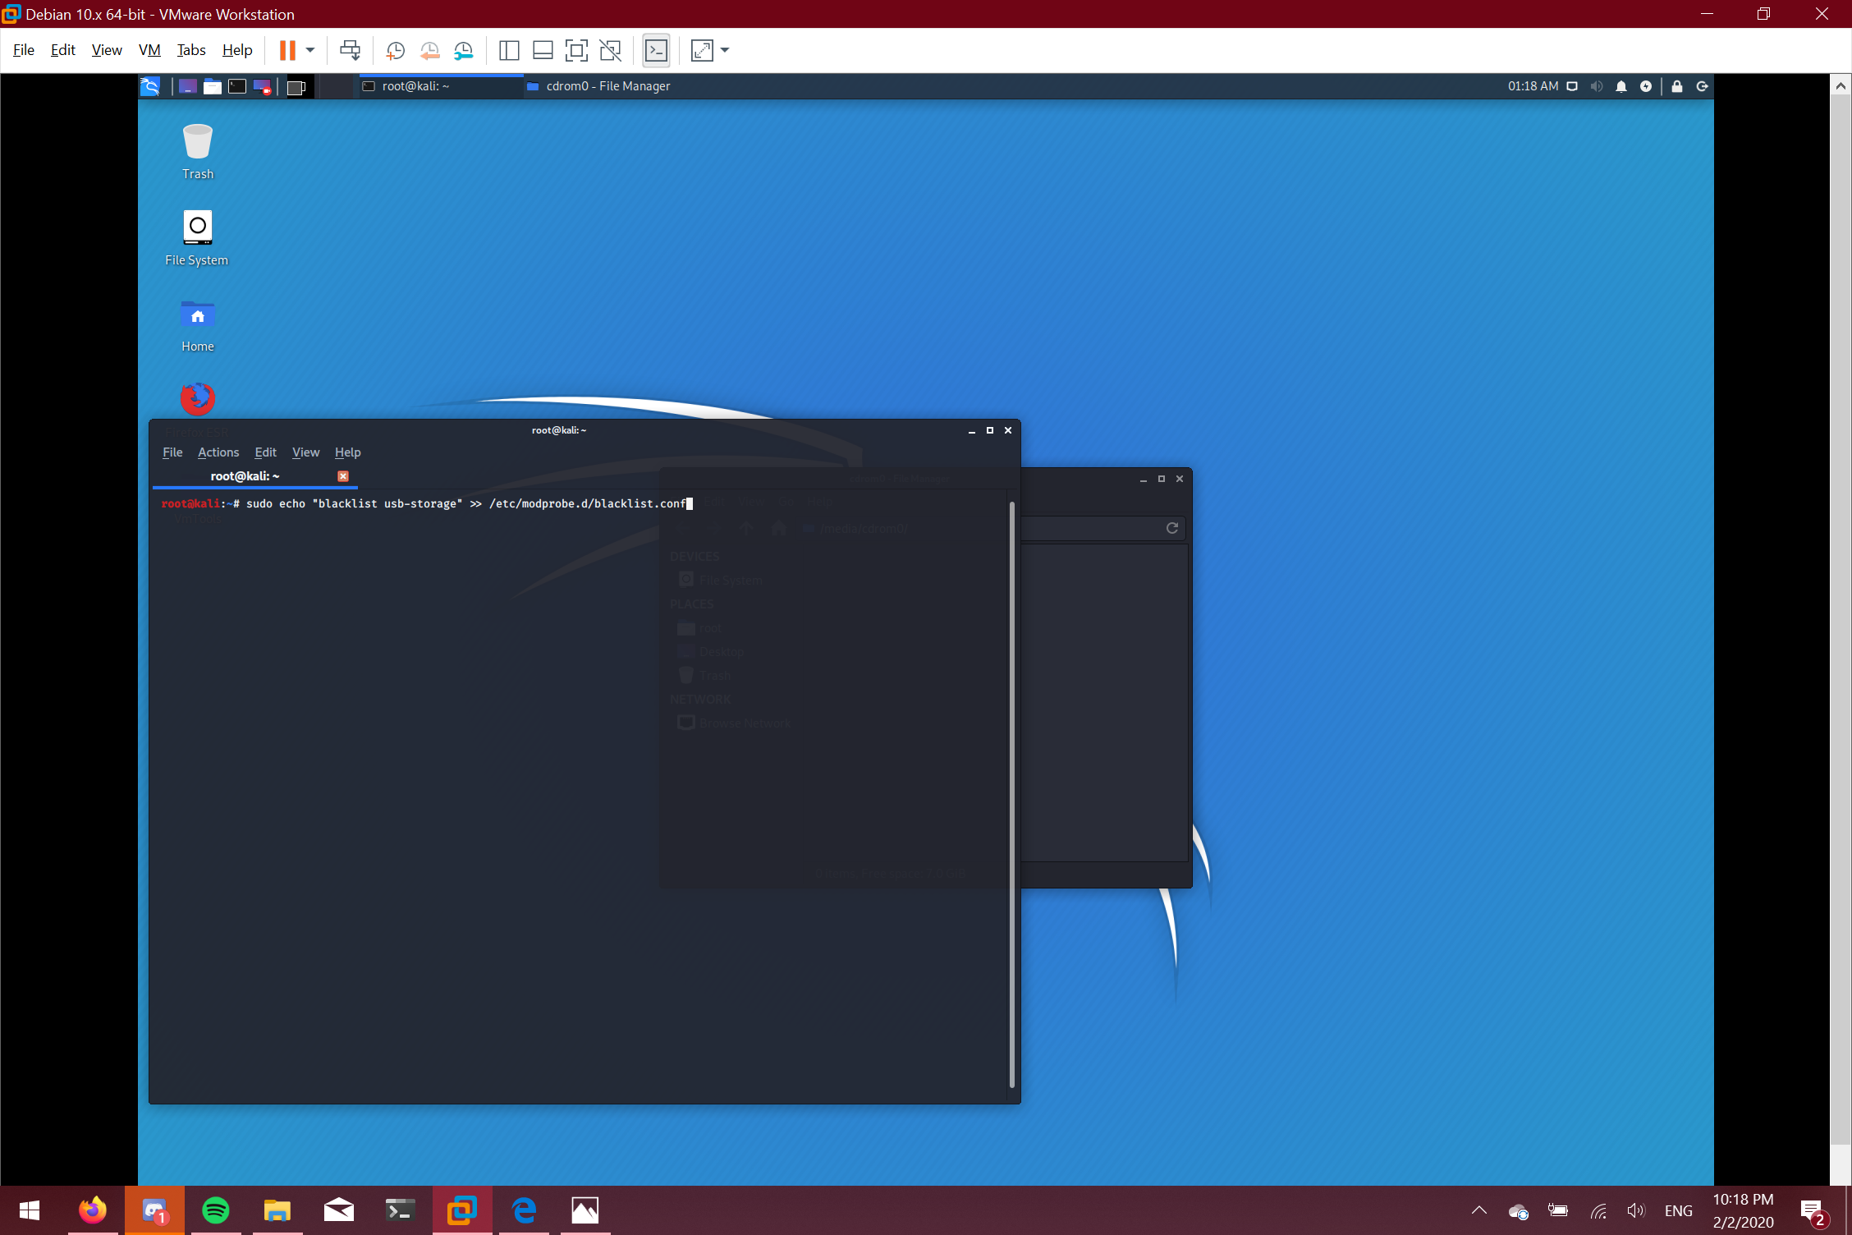

**Create a new user:**

Type the command given command, but replace shiro with the desired username

Then follow the instructions that follow

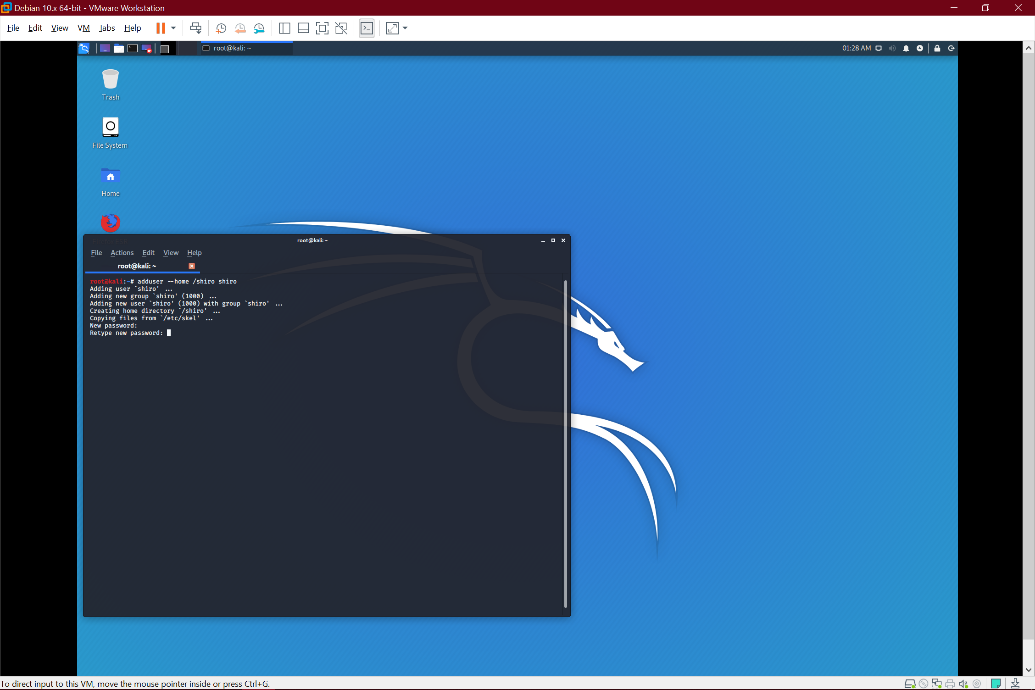

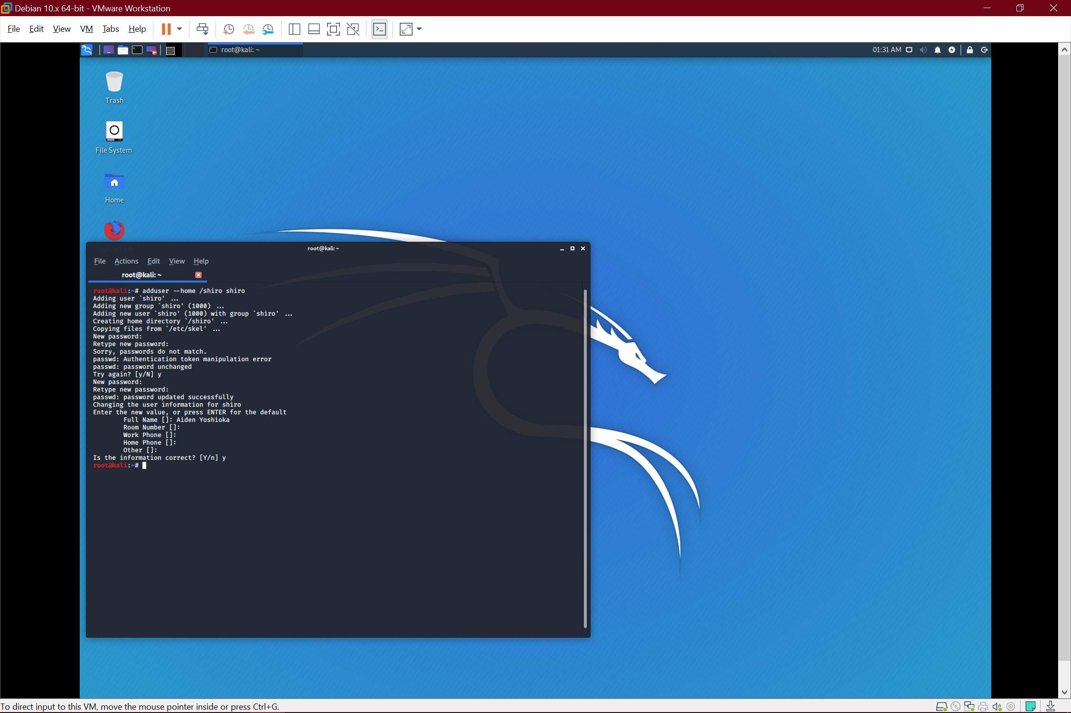

**Set password expirations:**

Checking when shiro’s password expires

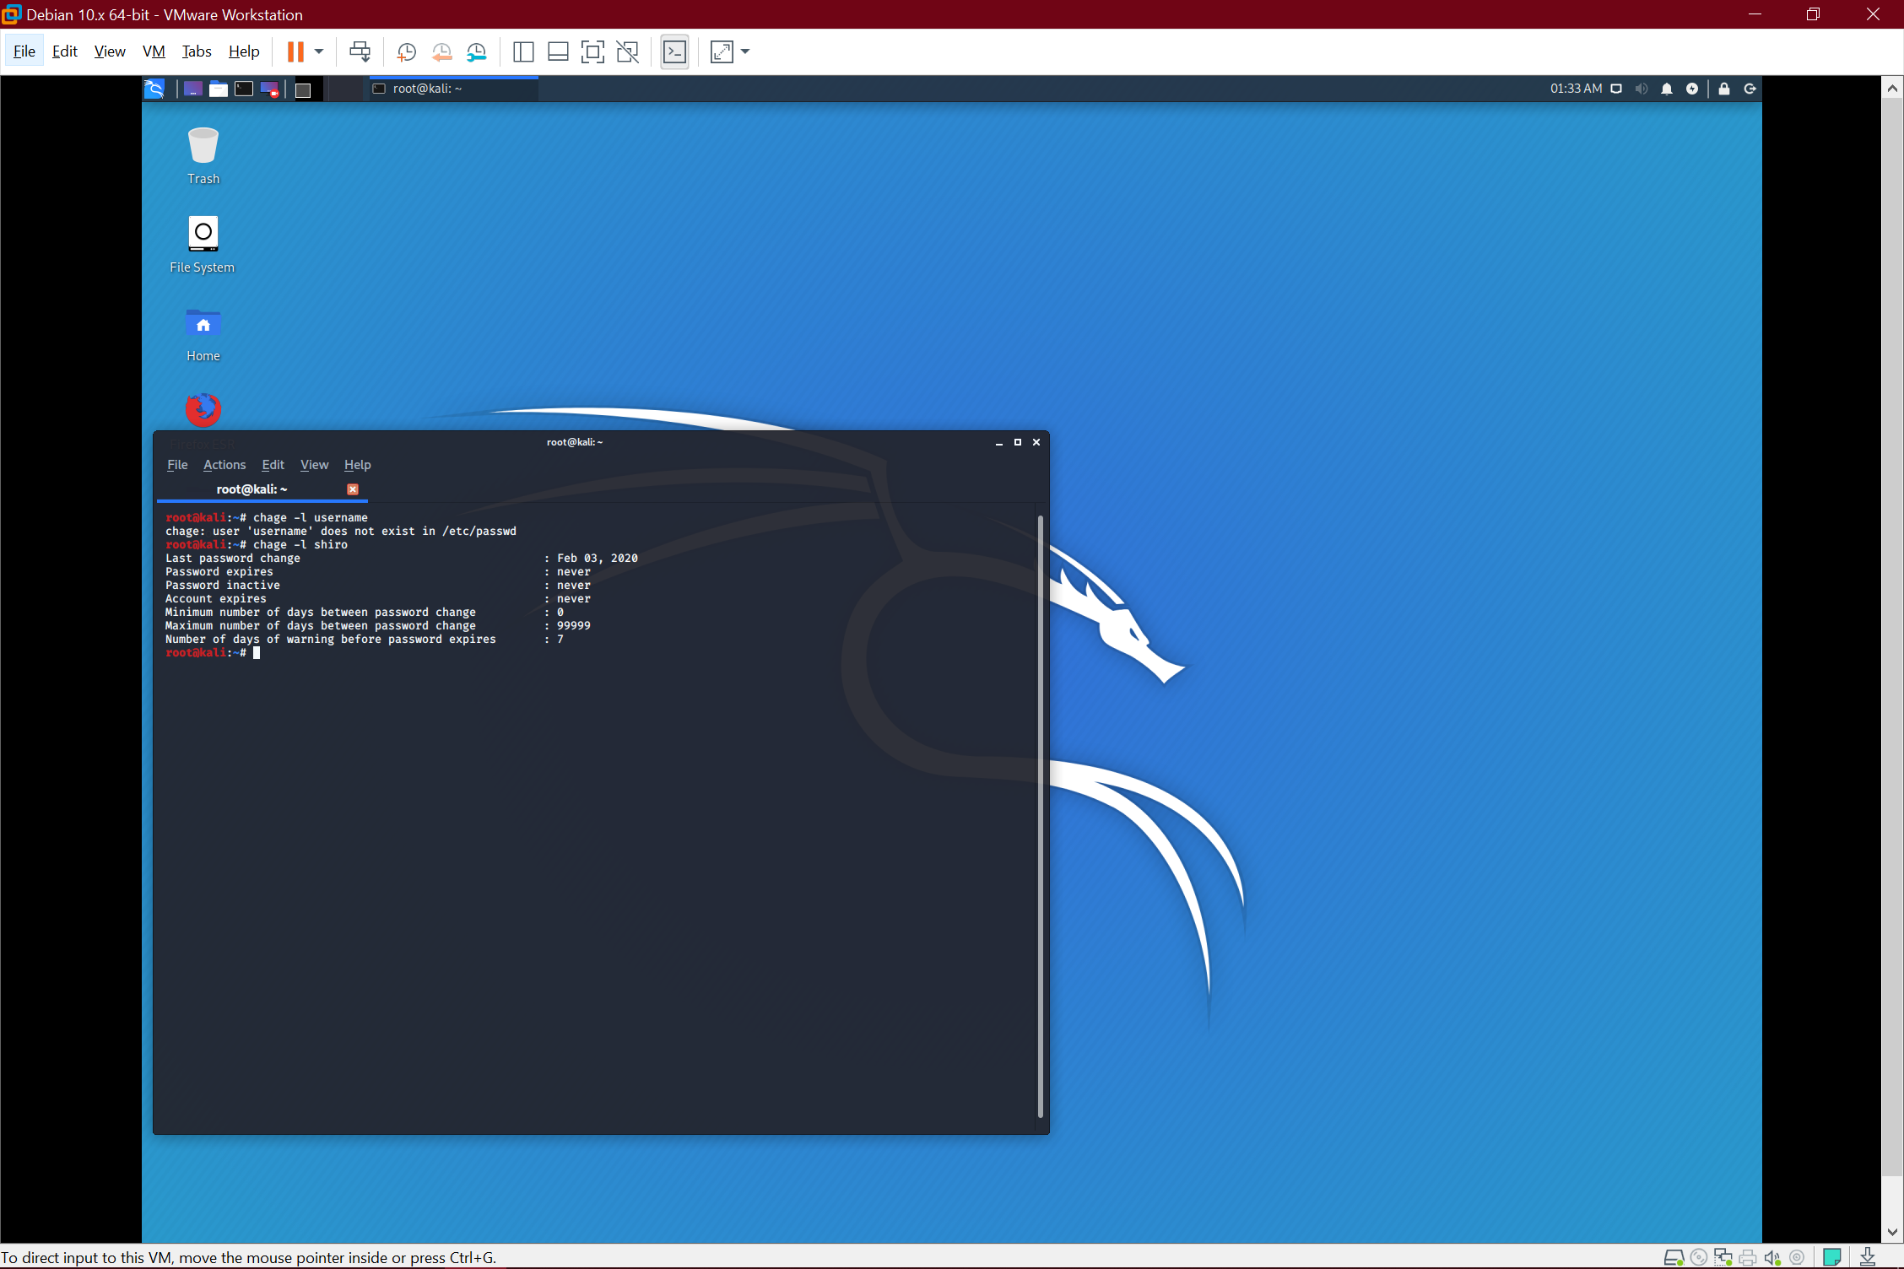

Setting shiro’s password to expire in 60 days with: chage -M 60 shiro

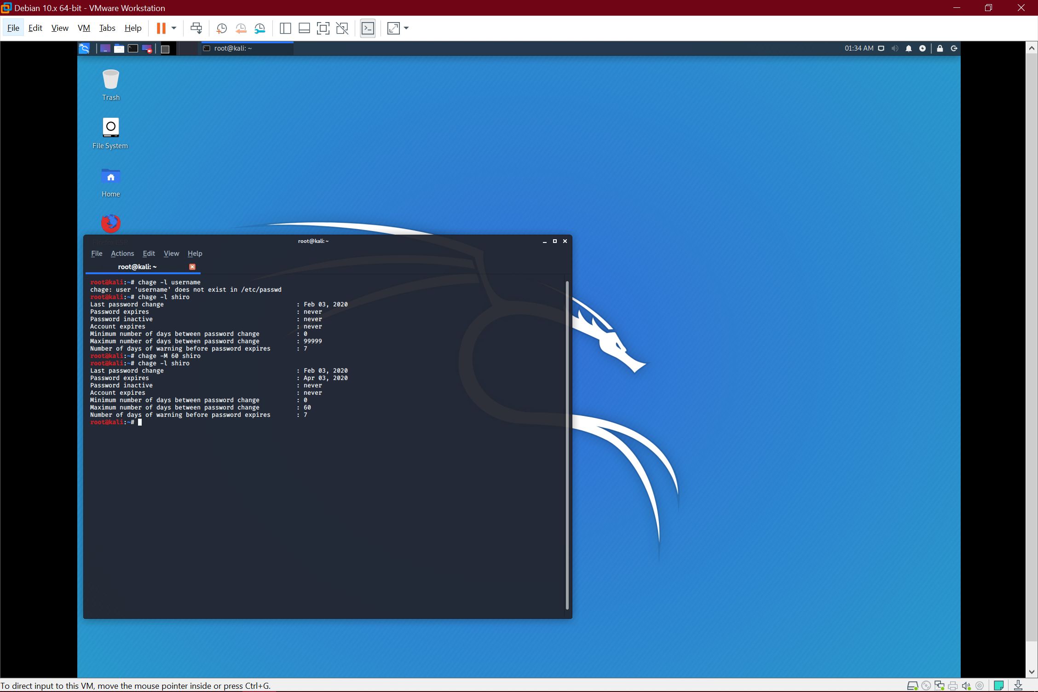

**Turn on account locks after failed attempts**

I’m locking shiro after 10 failed attempts: faillog -m 10 -u shiro

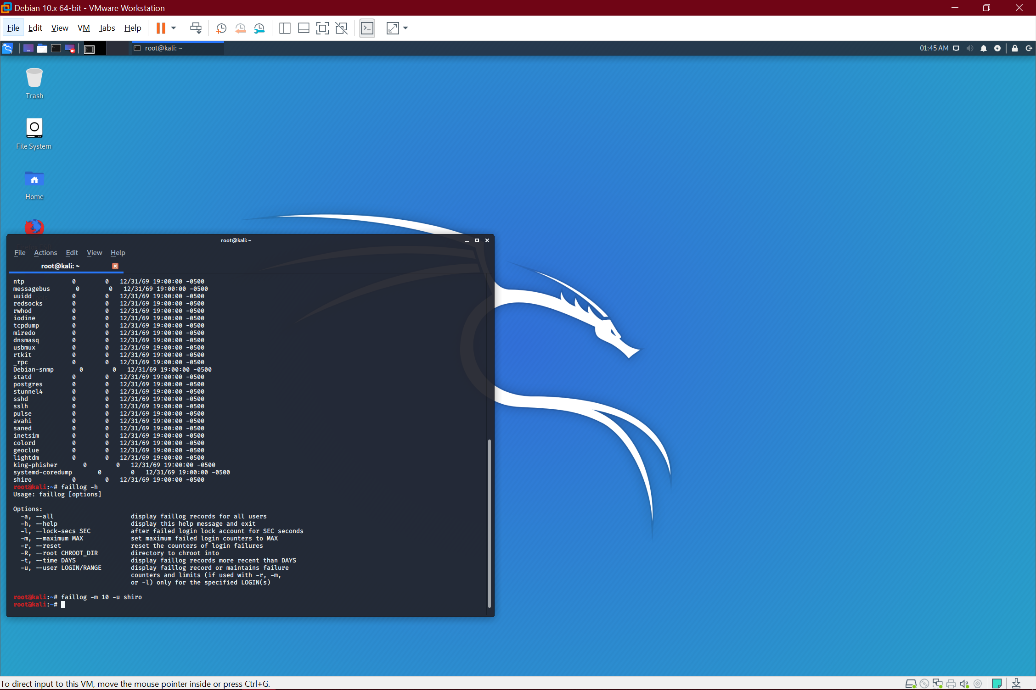

**Disable unneeded services:**

Display all services with systemctl

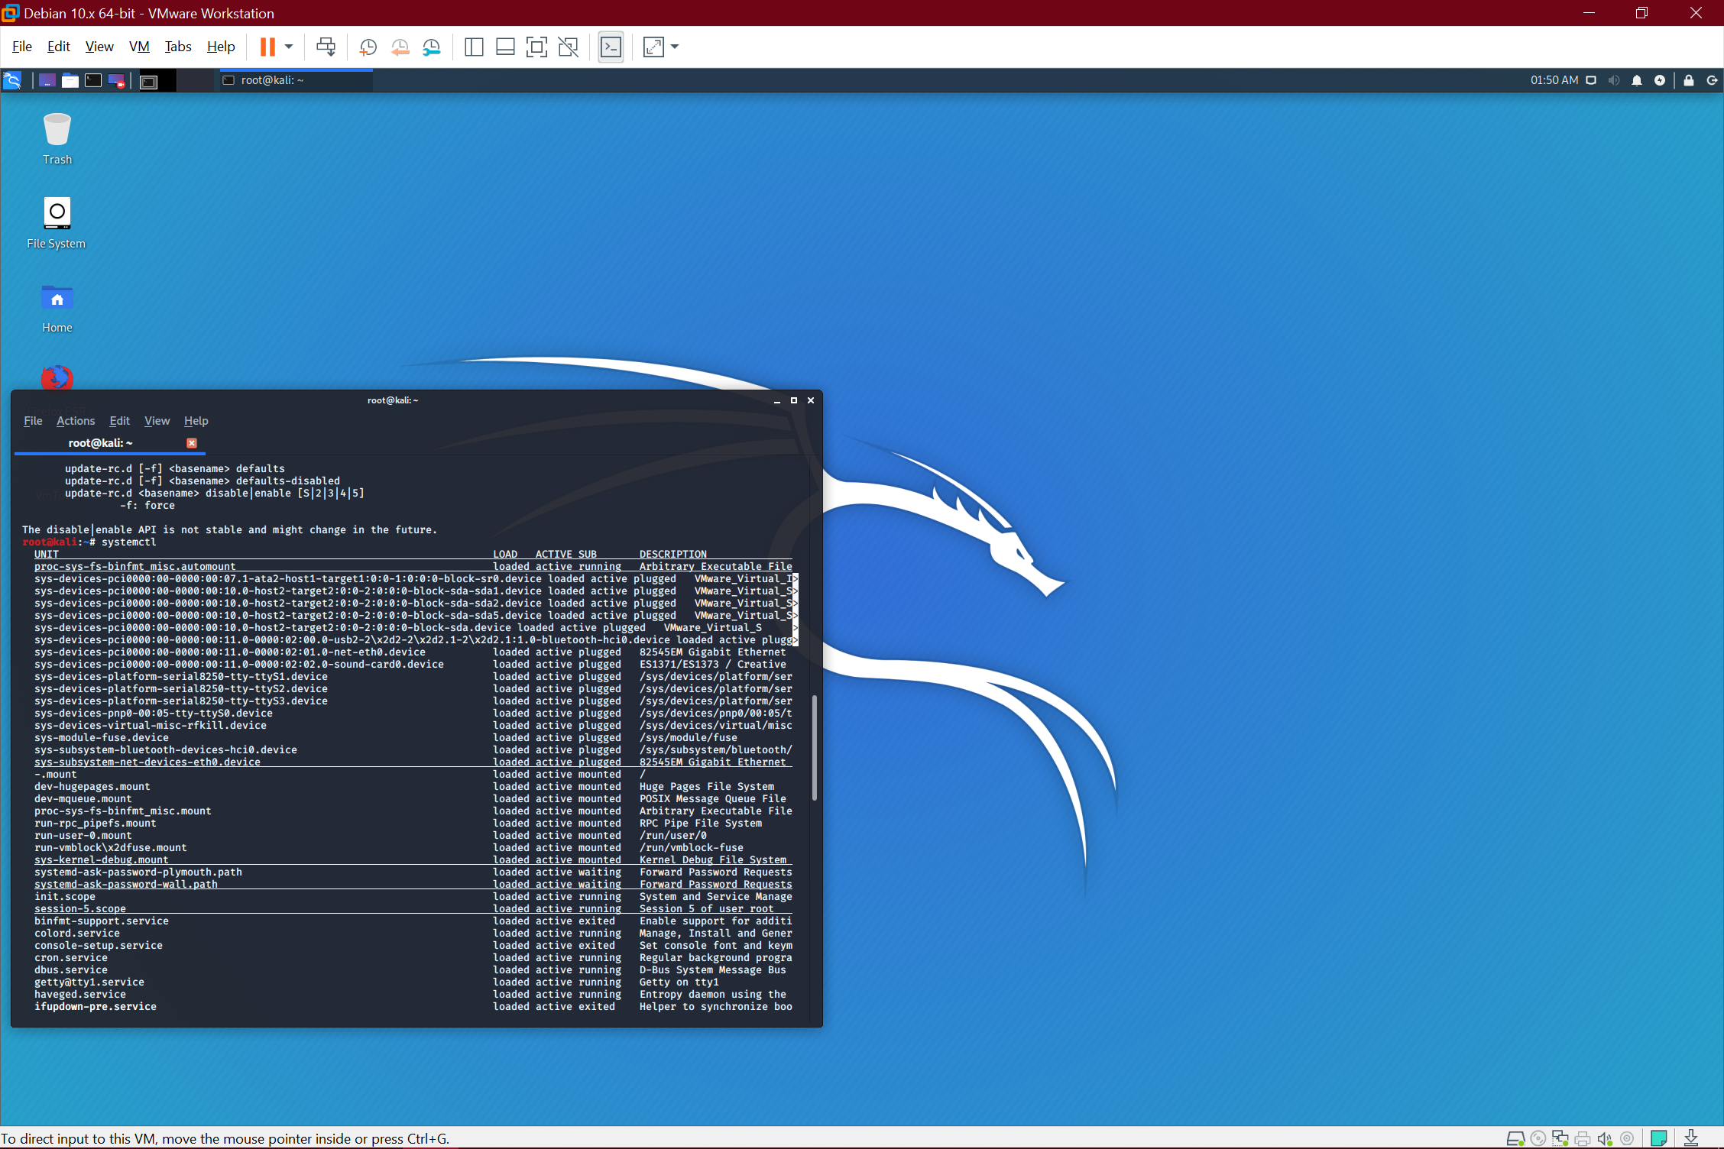

Disable unwanted services with service <service name> stop

I already did so, but I will demonstrate with network manager (Don’t do this, it disables your wifi)

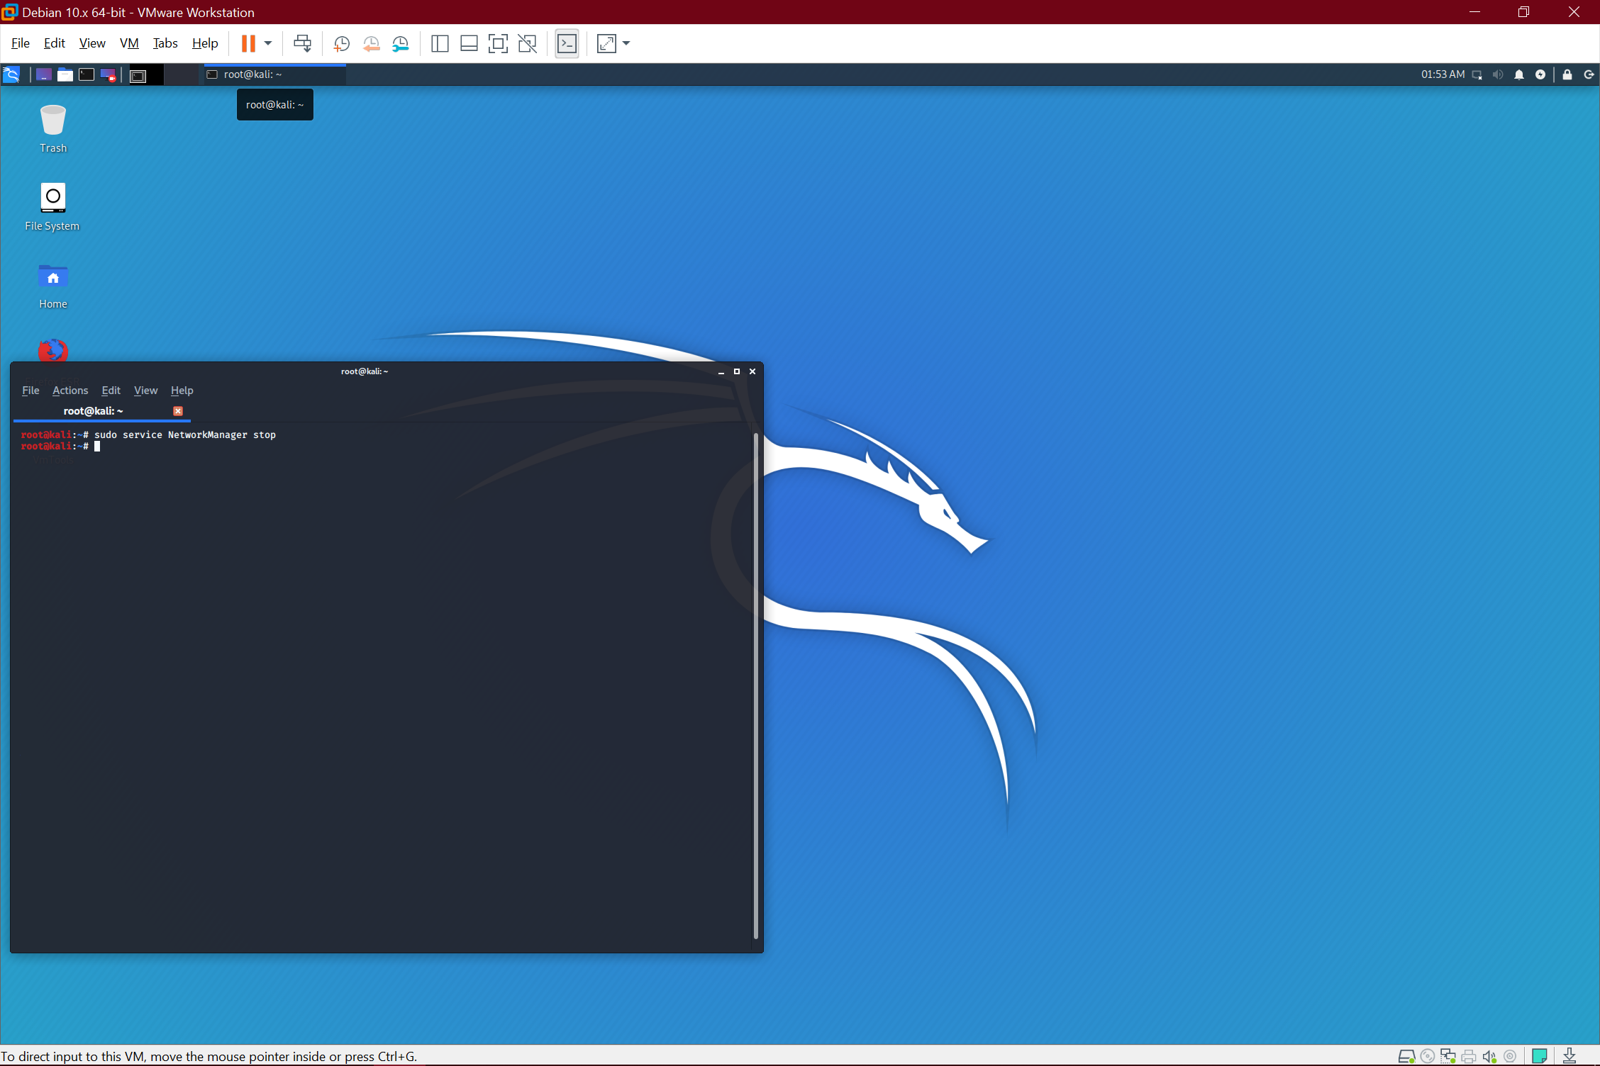

**Download an anti-virus software:**

I don’t plan to do anything intensive, so I’ll just start with sophos

Download sophos from the website

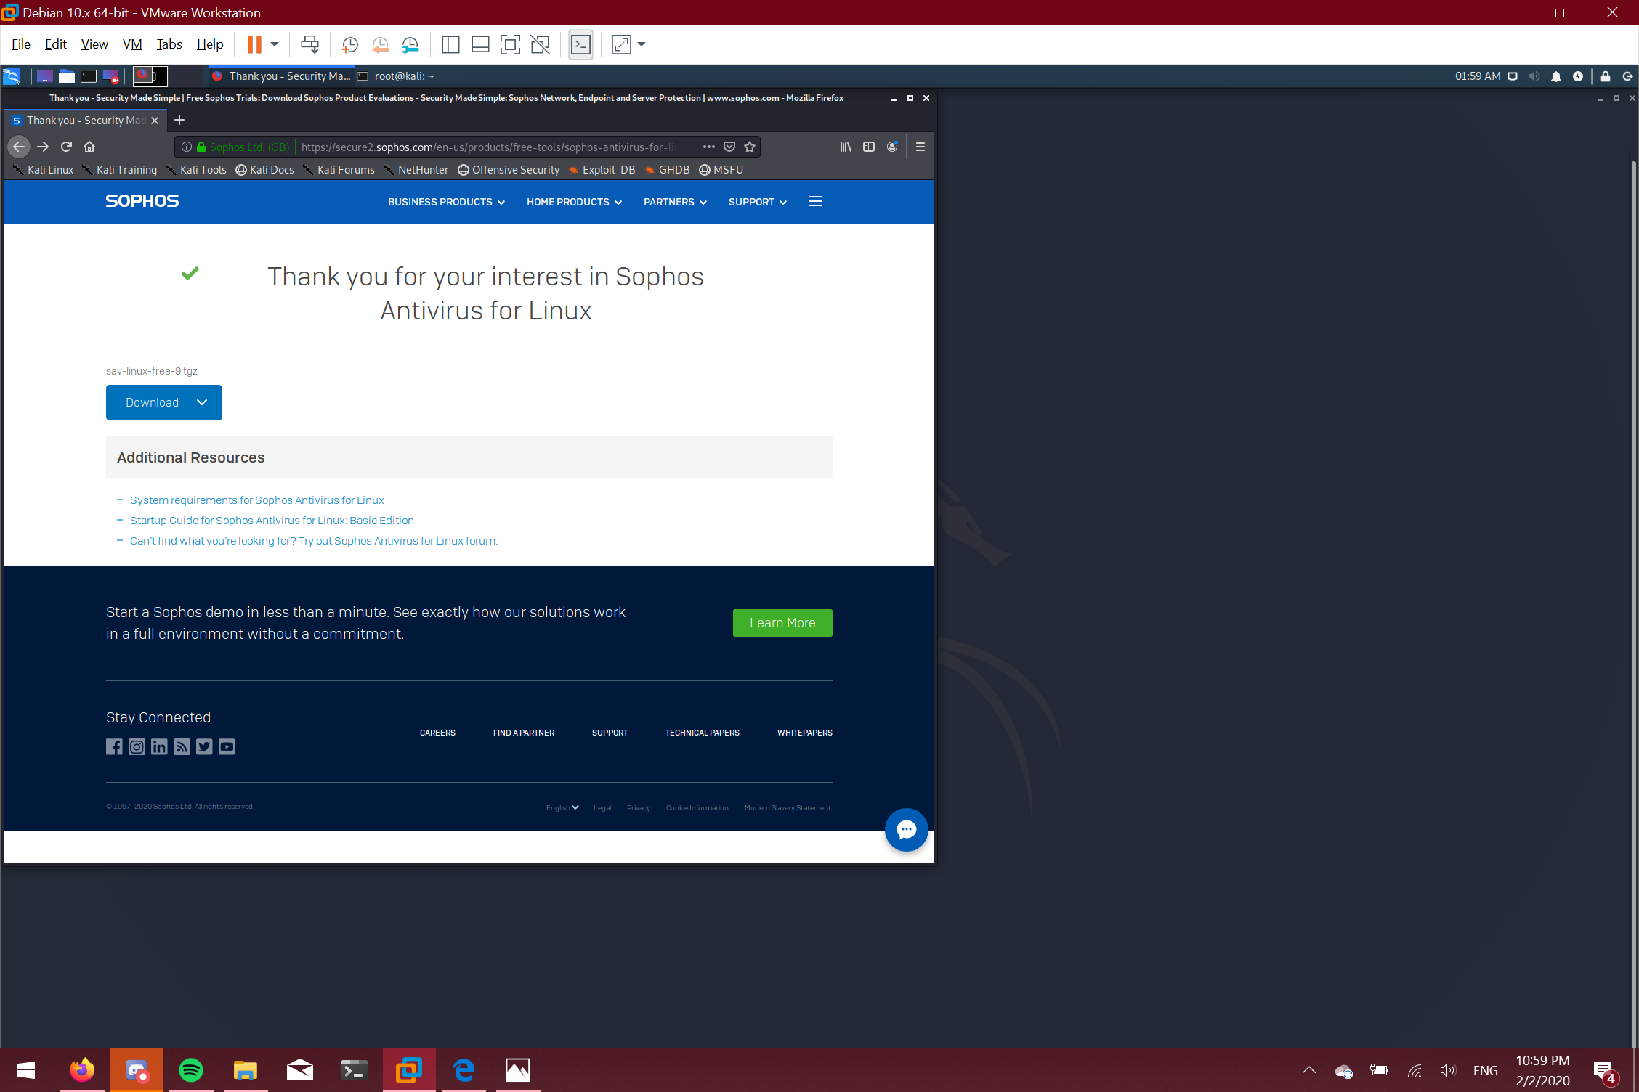

cd to ~/Downloads/ and type sav-linux-free-9.tgz

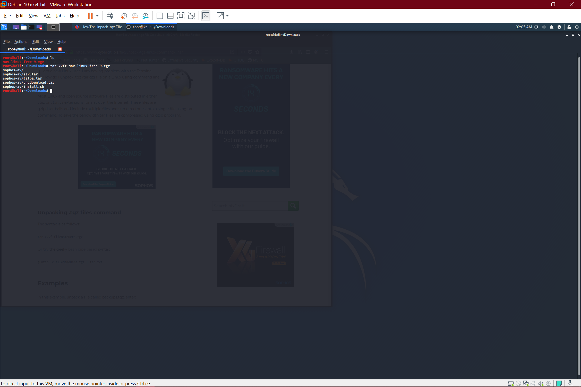

Go into the sophos directory with “cd sophos-av” and type “sudo bash install.sh” . Press space then enter to navigate through the terms. type yes when necessary. When it asks for auto updates answer with “n”

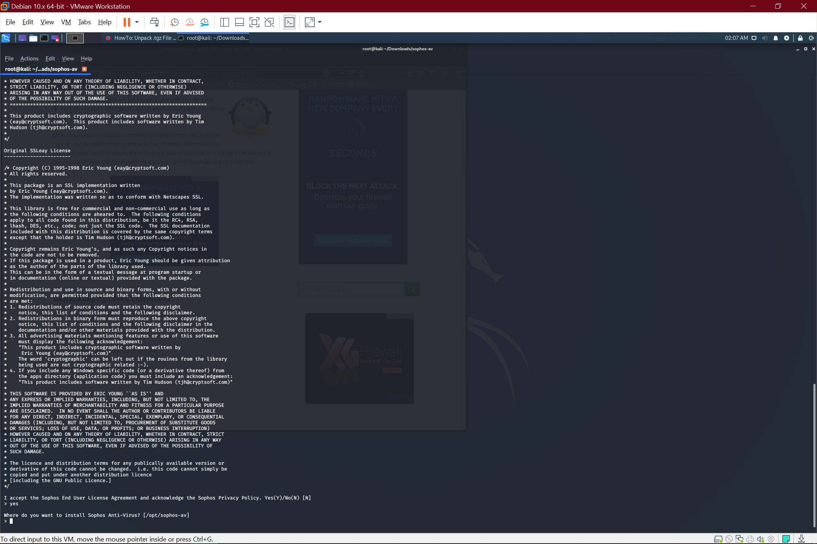

Now you can scan any file using sophos

**Keep the system up to date:**

The easiest way is to run “sudo apt-get update && sudo apt-get upgrade && sudo apt-get dist-upgrade”. This makes sure you update all programs, upgrade all programs, and upgrade to any new distributions.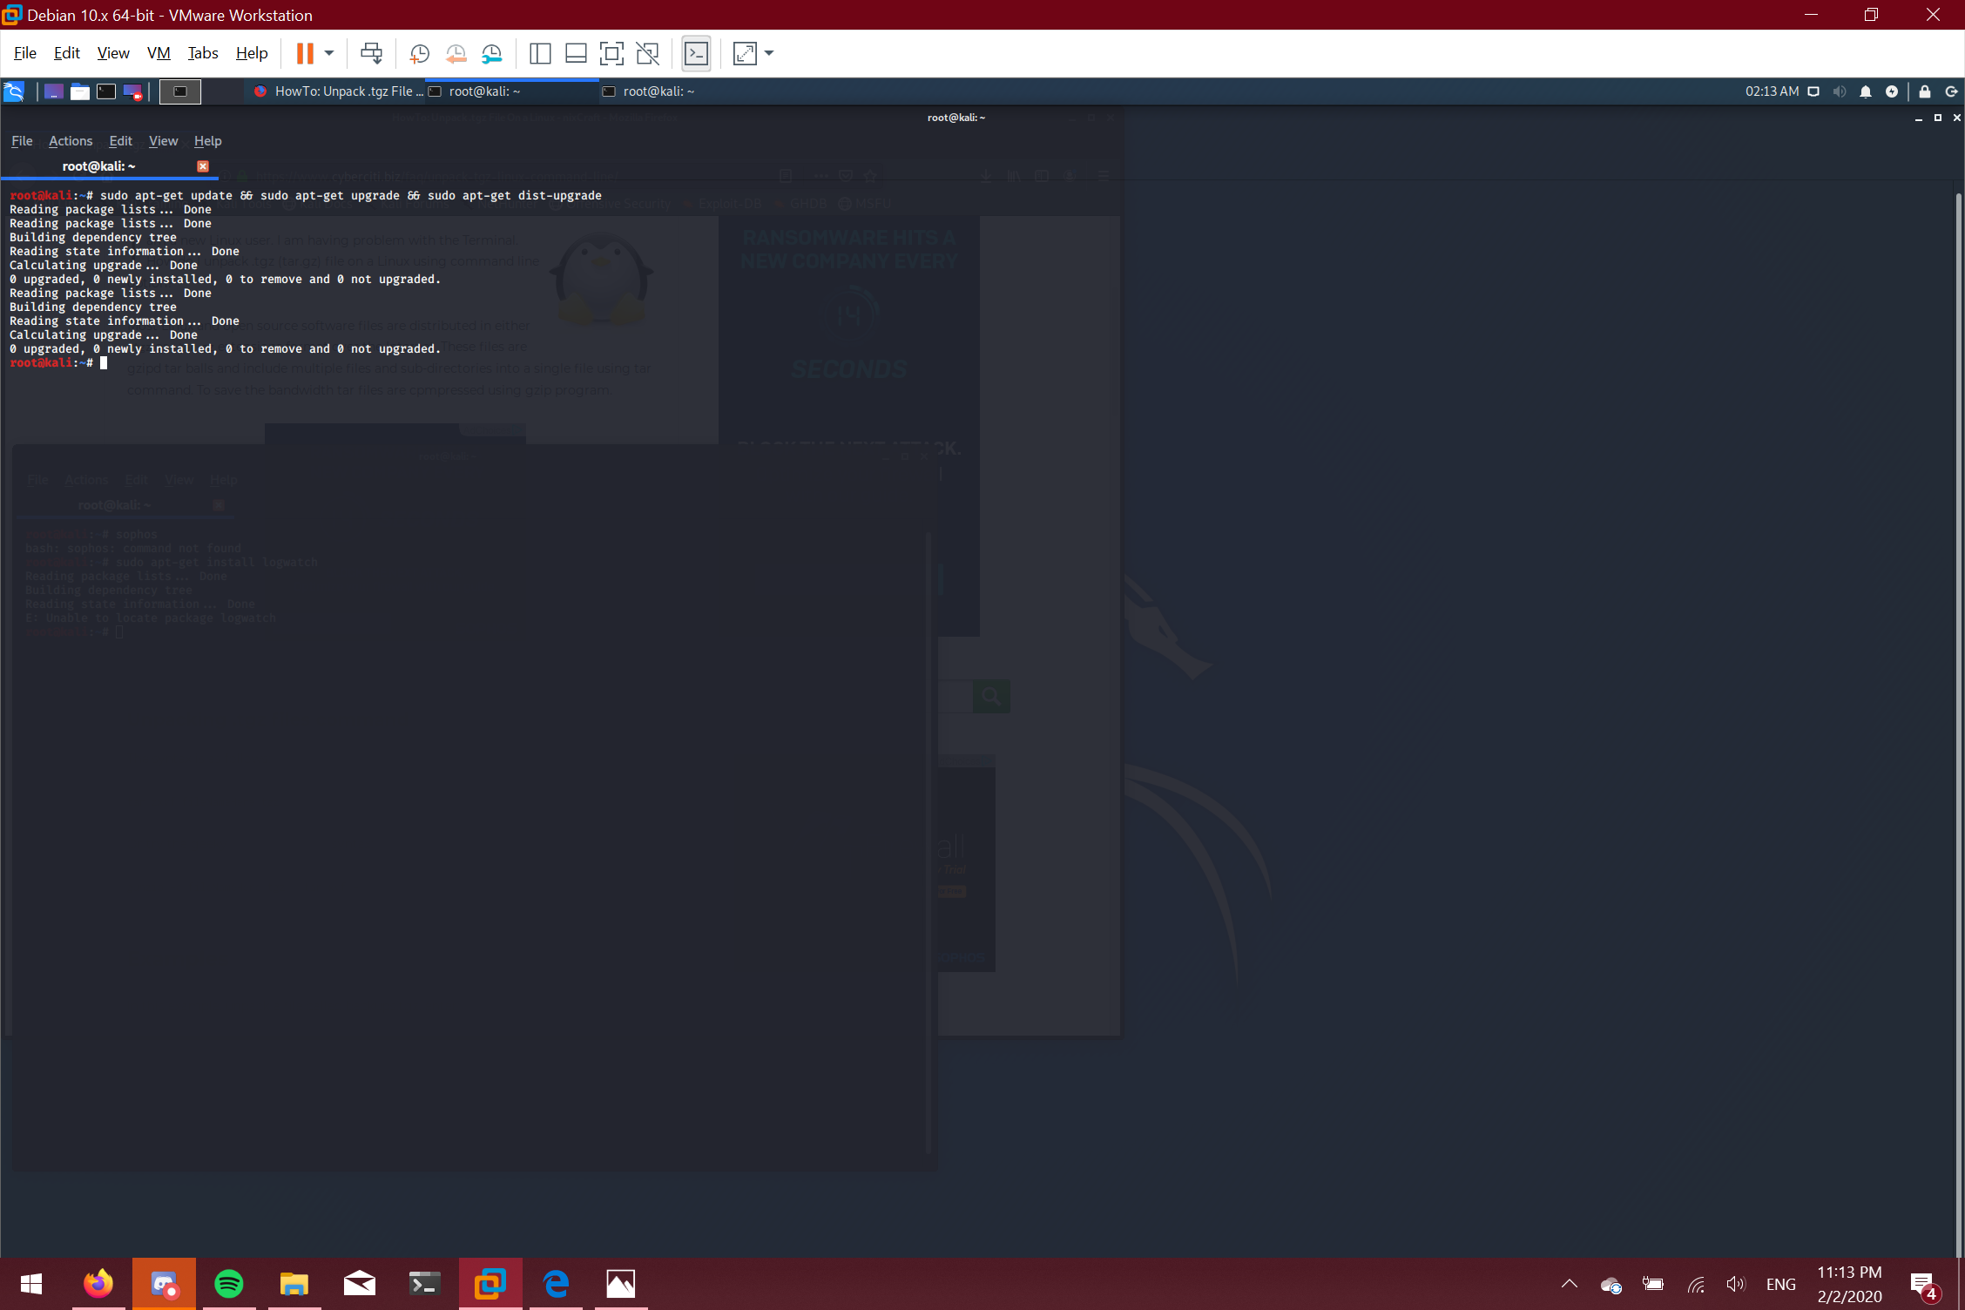

# Summary:

These aren’t all the techniques you can use to harden a linux system. However, these are some of the more beginner friendly methods I can think of. The best way to defend your system is to be proactive however. This means avoiding any suspicious websites/links, never joining open wifi, encrypting your disc, and making sure you don’t leave your computer unattended. There are some other tools you can also install on a linux system, however I wasn’t able to get them to work on the 2019 Kali distro. This is still a new distro to me since I use Parrot OS and ubuntu most of the time. These steps are on a Debian system, so the steps will be a bit different on other distros.